1. Donation category: The provided categories are the only ones your application must support. The ability of employees / locations to create custom categories, or to have even more categories (or even a hierarchical structure) is extra credit.
2. Login: Security logging, password encryption, or account lockout is not required for implementation and would be extra credit for later in M12.
3. Registration: In a real application, we would have controls for determining this, but for this class project, we will have registration designate accounts as basic Users. You may implement creation of other account types for extra credit.
4. Databases are extra credit; therefore, you can assume for testing of this app all data will fit into the device memory.
5. Donation attribute: Note that photos and comments are optional extra credit items.
6. 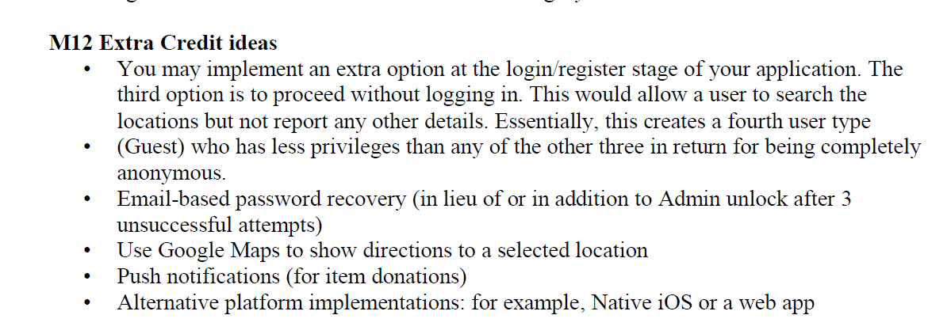Search Items: Search by item name. The user enters a specific item name and your application should display all items with that name. Note: Fuzzy searches and partial matches are extra credit.